Evolution Chair Applications
Office – Healthcare - Home- Classroom

The jury is in. Sitting all day every day is hazardous to your health. It causes muscle weakness and poor posture putting you at risk for back pain and injury.
Depending on your circumstances, you may have no other alternative than to sit for prolonged periods of time — but you do have choice on how you sit and what you sit on.
The solution is to take pressure off your spine, release muscle tensions and strengthen your core through "active sitting" on a chair that provides dynamic movement.

Technology has made our lives easier but it’s also made us more sedentary. As a result our health has paid a price. Poor posture, weak core muscles, back pain, reduced blood flow and poor concentration are just a few of the consequences of sitting all day every day.

Traditional Chair vs Stability Ball Chair
Typical ergonomic chairs do provide support but since they keep the body in a static position, postural muscles begin to tire and weaken after a short period of time.
Rigid chair = rigid back.
Since your body is designed to move and sway, exercise balls are a far superior choice. The dynamic movement created to maintain your balance not only keeps your spine aligned, but strengthens your core muscles.
Active sitting = strong flexible back.

The Stability Ball Solution
Since stability exercise balls are unstable, they force you to keep moving to maintain balance. This “active sitting” automatically encourages proper spinal alignment and activates nerves which signal core muscles to contract. The dynamic movement builds and tones back and abdominal muscles, improves balance, and actually burns off some extra calories.
But it’s not just your muscles and skeletal structure that benefits. The constant bounce and sway enhances circulation, nourishes the organs, boosts energy and even improves your ability to focus.
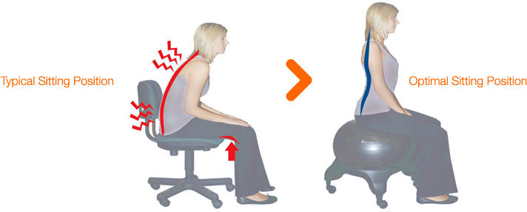

Evolve with the Evolution Chair. Building Healthy Bodies for Healthy Work Environments.

