User Guidelines
Sitting on the Evolution Chair™ builds the multifidus, rotatories and transverse abdominus muscles that lie deep within the trunk—small spinal stabilizers that condition the body's core.
As with any new exercise routine, it is important to gradually build up your strength as your body gets accustomed to sitting on the ball. For optimum results and to prevent muscle strain, please follow the chart below which outlines suggested daily incremental usage. And most importantly, remember to get up and stretch every hour!
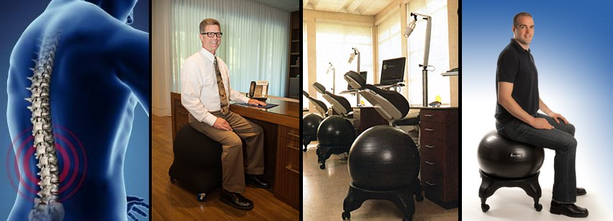

How to Use Evolution Chair™
Your body will need time to get accustomed to sitting on the ball. Please follow our suggested usage instructions for an incremental approach starting with short periods for your first week, then progress to longer sitting periods.

Week One
Day | Duration on Evolution Chair
1 | 15 minutes
2 | 20 minutes
3 | 30 minutes
4 | 40 minutes
5 | 1 hour
6 | 1 hour 15 minutes
7 | 1 hour 30 minutes

Week Two
Day | Duration on Evolution Chair
1 | 1 hour 45 minutes
2 | 2 hours
3 | 2 hours 15 minutes
4 | 2 hours 30 minutes
5 | 2 hours 45 minutes
6 | 3 hours
7 | 3 hours 15 minutes

Week Three
Day | Duration on Evolution Chair
1 | 3 hours 30 minutes
2 | 3 hours 45 minutes
3 | 4 hours
4 | 4 hours 15 minutes
5 | 4 hours 30 minutes
6 | 4 hours 45 minutes
7 | 5 hours

Week Four
Day | Duration on Evolution Chair
1 | 5 hours 15 minutes
2 | 5 hours 30 minutes
3 | 5 hours 45 minutes
4 | 6 hours
5 | 6 hours 30 minutes
6 | 7 hours
7 | 8 hours

